Audio Separation Comparison: Clustering Repeating Period and Hidden Markov Model

Yao Yao

MSDS 7335 402

Machine Learning Comparison Project

**Introduction**

Contemporary music is created by layering and mixing various vocals over different instrumentals [Figure 1]. Separation can be messy and mostly supervised because unsupervised results could be trivial, where the original isolated sounds could be commonplace. Music theory suggests that a collective synchronization is necessary for different components to form melodies to create a sensation of an ordered harmony, which allows the hearing sense to separate disordered noise from musical sophistication [2].

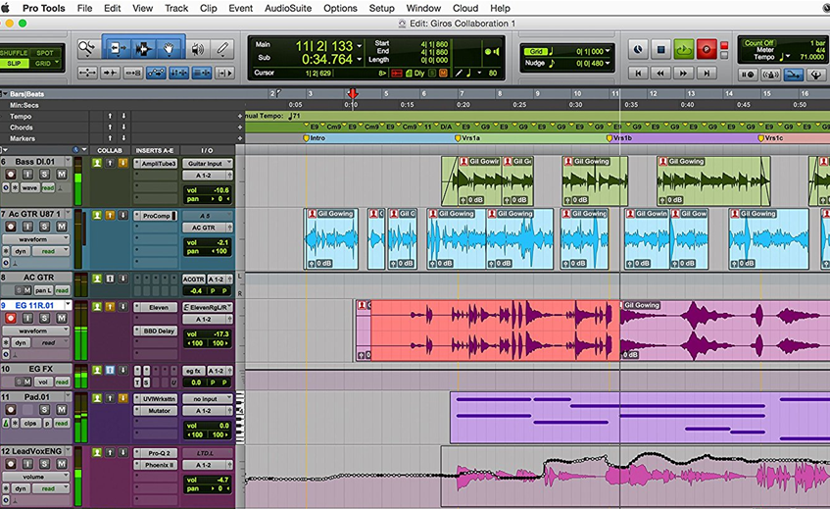

**Figure 1:** Pro Tools can be used to mix and layer different sound components such as bass and lead vocals into a full contemporary song [3]. The bottom "LeadVoxENG" shows uneven sound manipulations

Sound is overlaid on top of each other on a 3D scale and could be visualized by a spectrogram, but separation by percussion, harmonics, or various unsupervised spectra signatures is arbitrary and could be recognized as borderline noise instead of a collective syncopated harmony. There are no adequate validation tracks for arbitrary unsupervised separation. The goal is to have collective harmony in the separation, where structural sound integrity also needs to be intact after separation for the sound texture to sound full as the original. Machine learning could be applied to separate vocals from instrumentals, which has validation tracks and has real life application because DJs can use various a cappellas on top of various instrumentals to create blend tapes [4].

Audio separation techniques have existed prior to and could be enhanced by that of machine learning, such as the clustering repeating period technique and trained Hidden Markov Model. Techniques could be validated with official versions of the separated audio, where single CDs provide the main mix and the separated instrumentals and a cappella versions for their respective validation. Listening to high accuracy results could be enjoyable and the best techniques could be applied towards audio where official versions of separated instrumentals and a cappella are unavailable.

**Dataset**

Promotional CD and vinyl distribution of single songs, where the main mix also includes the instrumental and a cappella versions could be used for the do-it-yourself (DIY) separation and the validation of the results. In this real life example, different separation techniques are applied to a song released in 1998 by Aaliyah called "Are You That Somebody" with a song length of 4 minutes and 28 seconds [5]. The .mp3 compressed file has a bit rate of 128 kB/s, where the 3.7 kB file is converted into .wav to be machine readable at an uncompressed size of 23.1 kB. The output of the separated DIY instrumental and a cappella are uncompressed .wav files of about 23 kB each for the Python validation process and then converted into to .mp3 to a size of about 4 kB. The validation .mp3s are from the same single CD where the official instrumental and a cappella are available as 3.4 kB and 3.5 kB, respectively.

The Multimedia Information Retrieval Dataset has 1000 pre-labeled a cappella, instrumentals, and both for the 70% training, 20% testing, and 10% validation process [6]. The .wav files (516 MB total) have a stereo sample rate of 16KHz, where male and female vocals last 4 to 13 seconds to create a supervised Hidden Markov model with their respective spectral patterns.

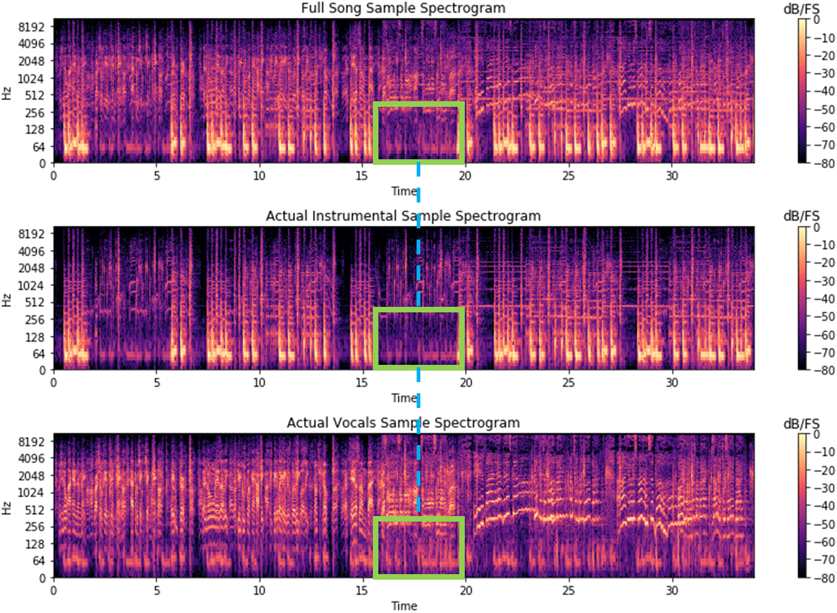

**Figure 2:** A 35-second sample of spectrogram at 1:28 of the song. dB and Hz structure can maintain similar magnitude across separated audio. A threshold allowance

Upon plotting the spectrograms of the full song, official instrumental, and official a cappella, we see from the CD files that horizontal lines are more likely instrumentals and curved lines are more likely vocals [Figure 2]. dB and Hz structure can maintain similar magnitude across separated audio and the separation technique is not a simple subtraction where vocals are carved out. The sound integrity does not diminish after separation and a threshold allowance called 'masking' is needed to gauge how much of the sound structure is allowed for each of the separated spectrogram to keep its structural sound integrity intact.

Simple subtraction separation techniques can lead to undesired results, where consequences of overcompensating for one output can deteriorate the other in quality resulting in grainy, robotic, or underwater vocals or instrumentals [Figure 3].

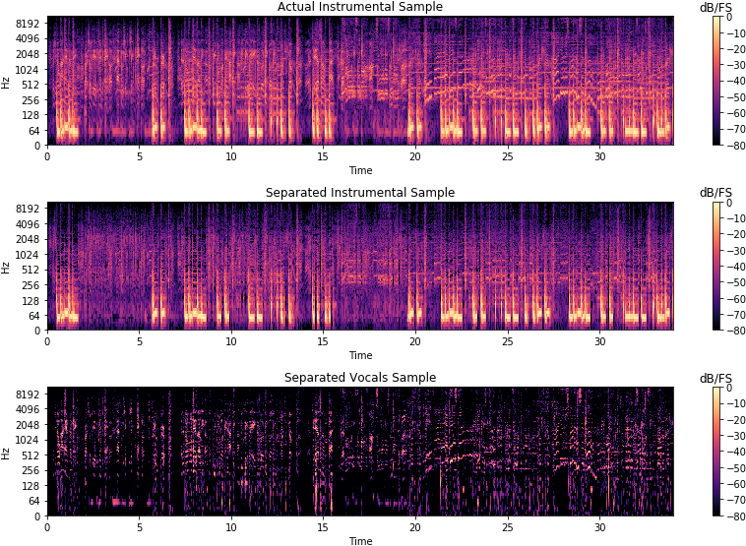

**Figure 3:** A 35-second sample of spectrogram at 1:28 of the song after simple subtraction. Consequences of overcompensating for one output can deteriorate the other in quality

**Method**

For the clustering repeating period procedure, the original spectrogram is used to create a median repeating segment per time period (p), where the period is optimized by the instrumental pattern that repeats [Figure 4] [7]. The separated instrumental is created from how far from median repeating spectrogram is allowed to repeat along original while the separated a cappella is created by the outliers of a threshold from the median repeating DIY instrumental. Thresholds are needed because it is not pure subtraction separation, where the value to separate instrumental and to separate a cappella could be different [6].

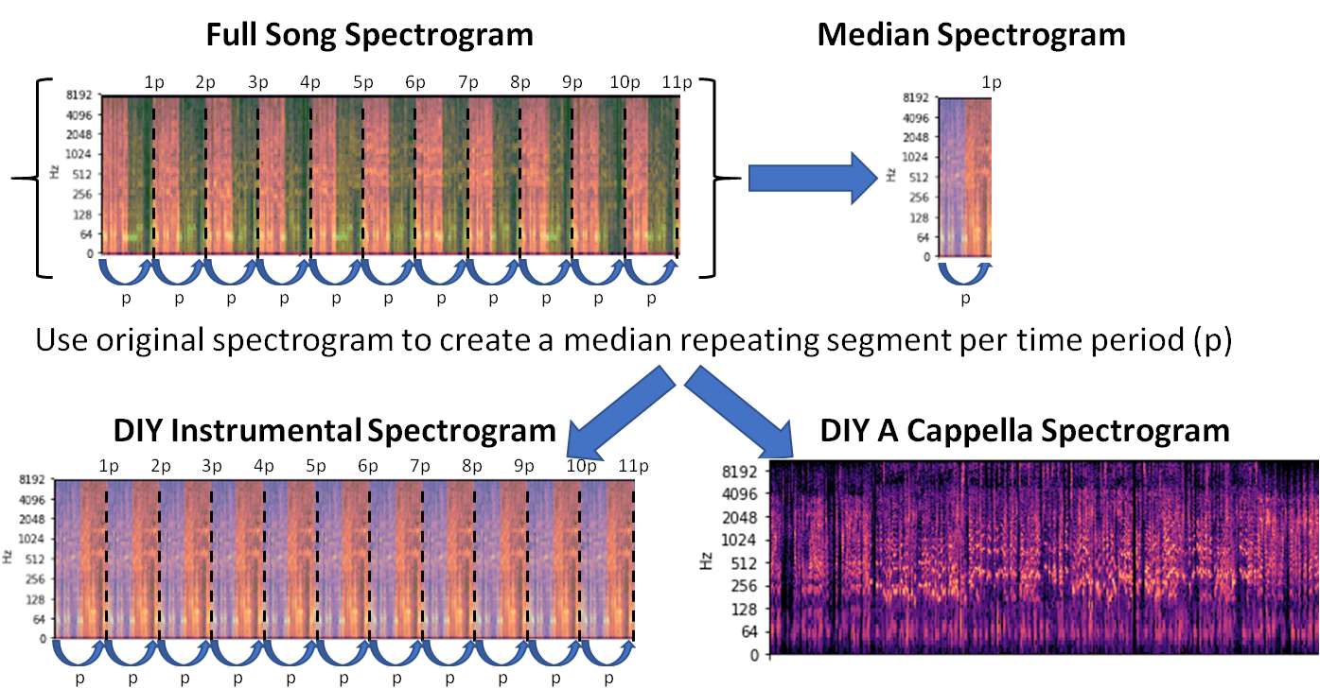

**Figure 4:** DIY instrumental: How far from median repeating spectrogram is allowed to repeat along original. DIY a cappella: Outliers outside of a threshold from the median repeating DIY instrumental

For the supervised Markov model procedure, the labeled spectrogram dictionary of vocals and music are permutated by overlaying sounds together and by sequencing sounds together [Figure 5] [8]. The probability densities are calculated for transitional likelihood of both sound overlays and sequencing and matched with the highest probability pattern alignment with song spectrogram [9]. The instrumental and a cappella are separated from full song by subtraction with the matched sound overlay, where the results are dependent on the quality and diversity of dataset.

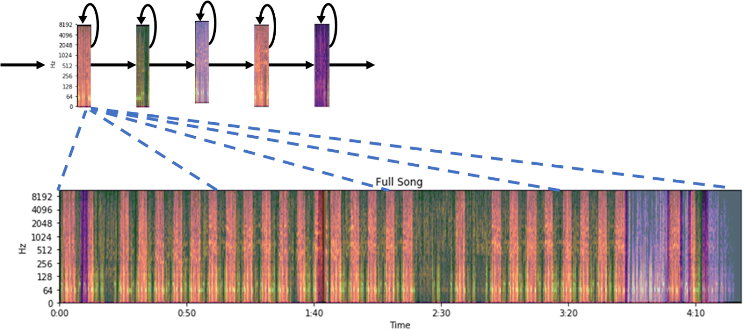

**Figure 5:** Hidden Markov Model is used to find the transition probabilities of certain sequencing and certain overlays of labeled sound from a labeled dictionary

For the validation procedure, the normalized distance between spectrograms is applied for the Mel-Frequency Cepstral Coefficients (MFCC) comparison [Figure 6] [10]. The comparison procedure first takes the Fourier transform of the spectrogram and maps the frequencies into pitch. Then a discrete cosine transform is applied to find the path and cost of comparison. The normalized difference is taken to find the absolute difference of how much distance the path deviates from a perfect 45° [10]. Both path and cost are plotted to show how the transformed data compare over time vs. time axes. After transformations, data integrity is kept but the units become abstract, where the normalized distance between full song and itself is 0.

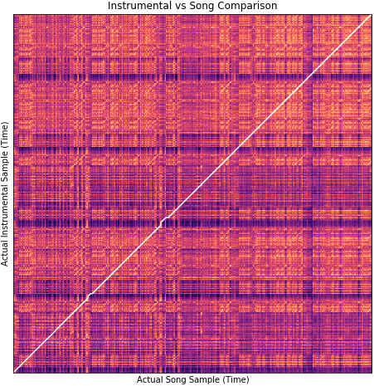 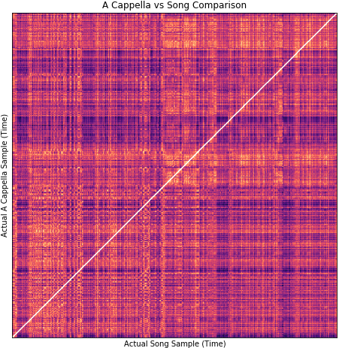

**Figure 6a and 6b:** MFCC comparison baseline test shows the scalar distance between the song and instrumental is 143.34 and that for the song and a cappella is 146.31

As a baseline test, the scalar distance between the song and instrumental is 143.34 and that for the song and a cappella is 146.31 [Figure 6]. The baseline numbers suggest that the distance between good DIY separations and the actual versions, respectively, should range from around 145 to 0. In the case of the bad example, the distance from real instrumental is 135 and the distance from real a cappella is 285 for their respective DIY separations [Figure 3].

**Results**

For the clustering repeating period method, the recurrence matrix is plotted using a diagonal redundancy similar to the MFCC transformations for the k-means clustering algorithm to recognize similar structural components of the periodic repetition of the song [Figure 7]. The k-means clusters are then overlaid on top of the full song spectrogram where the median spectrogram is optimized at a period that repeats every 6.9334 seconds [1].

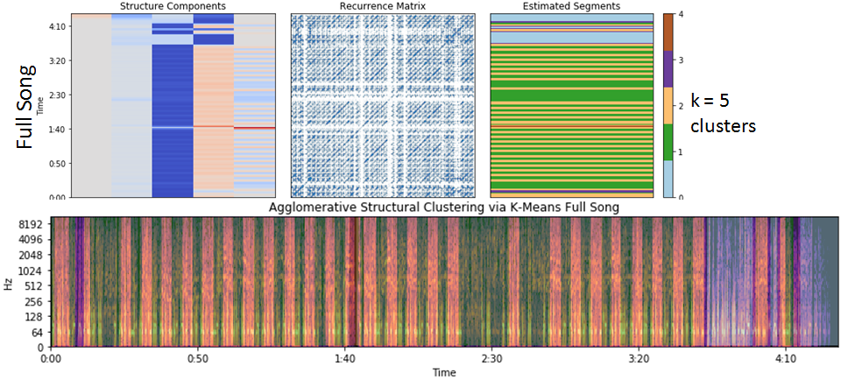

**Figure 7a and 7b:** Repetition visualized by the recurrence matrix could be clustered by k-means. Increase clusters to find optimal repetition via spectrogram overlay.

After optimizing parameters by ear, the normalized distance between separated instrumental and actual is 98.08, where the instrumental margin is 1 and the a cappella margin is 0.5 [Figure 8]. The normalized distance between separated a cappella and actual is 101.20, where the instrumental margin is 1 and the a cappella margin is 0.6 [Figure 9]. The fullness of the instrumental spectrum is preserved because of the median repeating period and the manually adjusted masking parameters. The a cappella separation has gaps in the spectrum despite the median threshold, perhaps because the median period also captured the redundant chorus that repeats over the song as well.

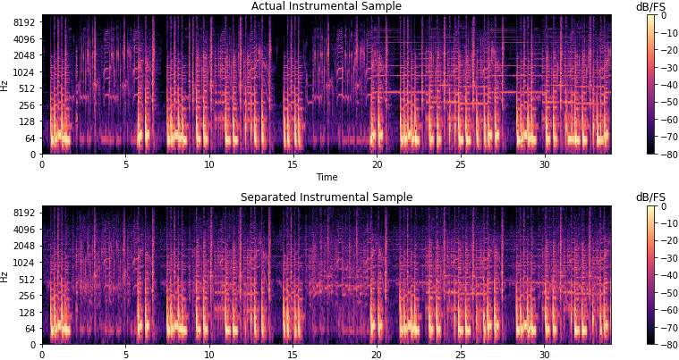

**Figure 8:** Clustering Repeating Period technique: normalized distance between separated instrumental and actual is 98.08, where the instrumental margin is 1 and the a cappella margin is 0.5

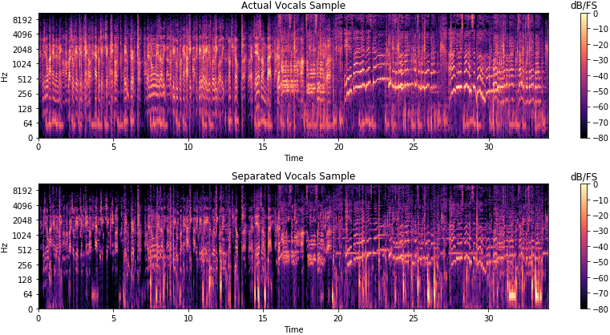

**Figure 9:** Clustering Repeating Period technique: normalized distance between separated a cappella and actual is 101.20, where the instrumental margin is 1 and the a cappella margin is 0.6

For the supervised Markov model, there is a time intensive approach to label, train, and iterate through the labeled dataset and the separation is dependent on the quality and diversity of the labeled dataset. The normalized distance between separated instrumental and actual is 100.6 [Figure 10] and the normalized distance between separated a cappella and actual is 111.6 [Figure 11]. The gaps in separation for both instrumental and a cappella are the result of misinterpreted matched probabilities that could be alleviated with sounds that match with the actual song.

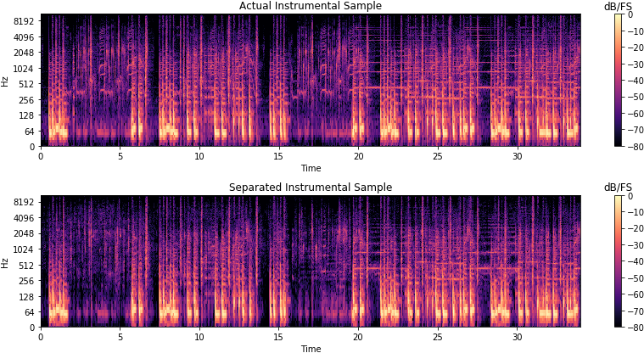

**Figure 10:** Hidden Markov Model: normalized distance between separated instrumental and actual is 100.6

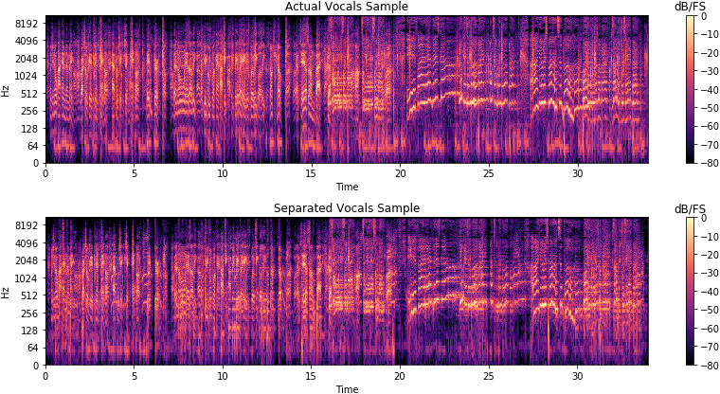

**Figure 11:** Hidden Markov Model: normalized distance between separated a cappella and actual is 111.6

**Conclusion**

For the clustering repeating period with optimization, the advantages include that the algorithm is fast and the dataset is self contained by the song file, whereas the disadvantages include that the sample limitations could result in an insufficient median and that it has to be manually optimized by ear. The distance between the separated instrumental and actual is 98.08 and that for the separated a cappella and actual is 101.20 for the clustering repeating period method.

For the supervised Hidden Markov Model with sound overlay and sequencing, the advantages include that the separation could be very precise depending on dataset, whereas the disadvantages include weird separation from probabilistic matching and the procedure is very time intensive with labeling, training, and iteration of the labeled dataset onto the song. The distance between the separated instrumental and actual is 100.6 and that for the separated a cappella and actual is 111.6 for the supervised Hidden Markov Model.

From this comparison, clustering repeating period with optimization is the better machine learning method by less time spent, more accurate results to the validation tracks, and the generality of the algorithm to be applied to unique songs without having to label more training datasets.

**Citations**

1. Y. Yao. "Audio Separation via Clustering Repeating Period vs. Hidden Markov Model," Github, 2018. [Online]. Available: https://github.com/yaowser/audio-separation [Accessed 6-Jun-2018]
2. G. Elert. " Music & Noise," The Physics Hypertextbook, 2018. [Online]. Available: https://physics.info/music/ [Accessed 6-Jun-2018]
3. "Pro Tools 12 Professional Annual Subscription," Amazon, 2018. [Online]. Available: https://www.amazon.com/Pro-Tools-Professional-Annual-Subscription/dp/B00V540NKW [Accessed 6-Jun-2018]
4. M. Weiss. "Tips for Mixing Vocals to an Instrumental," Pro Audio Files, 2012. [Online]. Available: https://theproaudiofiles.com/tips-for-mixing-vocals-to-a-two-track-instrumental/ [Accessed 6-Jun-2018]
5. "Aaliyah ‎– Are You That Somebody?" Discogs, 2008. [Online]. Available: https://www.discogs.com/Aaliyah-Are-You-That-Somebody/release/346060 [Accessed 6-Jun-2018]
6. C. Hsu. "MIR-1K Dataset," Google Sites, 2011. [Online]. Available: https://sites.google.com/site/unvoicedsoundseparation/mir-1k [Accessed 6-Jun-2018]
7. Z. Rafii. "REpeating Pattern Extraction Technique," Zafar Rafii, 2018. [Online]. Available: http://zafarrafii.com/#REPET [Accessed 6-Jun-2018]
8. J. Han. "Audio Imputation," Northwestern University, 2012. [Online]. Available: http://www.cs.northwestern.edu/~jha222/imputation [Accessed 6-Jun-2018]
9. A. Lloyd. "Hidden Markov Models in Practice," Slide Player, 2015. [Online]. Available: http://slideplayer.com/slide/4757315/ [Accessed 6-Jun-2018]
10. T. Tourani. "Comparing Audio Files Python," Github, 2015. [Online]. Available: https://github.com/d4r3topk/comparing-audio-files-python [Accessed 6-Jun-2018]